**BU51037**

**Data Visualization for Business**

# **Step 1: Dataset Selection**

This date is from kaggle: <https://www.kaggle.com/datasets/chirin/africa-economic-banking-and-systemic-crisis-data>

The dataset specifically focuses on the Banking, Debt, Financial, Inflation and Systemic Crises that occurred, from 1860 to 2014, in 13 African countries, including: Algeria, Angola, Central African Republic, Ivory Coast, Egypt, Kenya, Mauritius, Morocco, Nigeria, South Africa, Tunisia, Zambia and Zimbabwe.

It consists of 1059 records and 14 columns

The input variables include the following:

* systemic_crisis : "0" means that no systemic crisis occurred in the year and "1" means that a systemic crisis occurred in the year;
* exch_usd : The exchange rate of the country vis-a-vis the USD;
* domestic_debt_in_default : "0" means that no sovereign domestic debt default occurred in the year and "1" means that a sovereign domestic debt default occurred in the year;
* sovereign_external_debt_default : "0" means that no sovereign external debt default occurred in the year and "1" means that a sovereign external debt default occurred in the year;
* gdp_weighted_default : The total debt in default vis-a-vis the GDP;
* inflation_annual_cpi : The annual CPI Inflation rate;
* independence : "0" means "no independence" and "1" means "independence";
* currency_crises : "0" means that no currency crisis occurred in the year and "1" means that a currency crisis occurred in the year;
* inflation_crises : "0" means that no inflation crisis occurred in the year and "1" means that an inflation crisis occurred in the year.

**Step 2: Data Exploration**

There are no apparent issues regarding data type formats.

The dataset comprises 8 integer, 3 object, and 3 float columns

Notably, the 'banking_crisis' column indicates the occurrence of crises in 94 instances and no_crisis in 965

Further observation reveals a pronounced influx of data entries in the year 2014, suggesting a potential concentration of data during this temporal period.

**Step 3: Visualization Creation**

The line chart is an effective way to visualize the temporal trends and relationships between multiple variables, helping to gain a better understanding of the dataset in the context of the research question.

I made used of bar chart to displays the occurrences of banking crises across African countries which shows Central African Republic as more bank crises compares to others, each bar represents a country, and the height of the bar is the total number of banking crises.

Bar chart was used as well in this case since I want to show categorical data (countries) against average exchange rate to visualize a clear view of the country with the highest average exchange rate. Of course, Central African Republic as more average exchange rate compares to other Africa countries.

The box plot serves as a succinct data visualization tool, offering a compact summary of data distribution, including central tendencies and potential outliers. Through this tool, it becomes evident that Angola, Zambia, and Zimbabwe experienced a higher frequency of inflation crises compared to all other African countries. Conversely, South Africa stands out with the lowest incidence of inflation crises.

Pair plot visualizes the relationships and distributions between the selected variables (exch_usd, currency_crises, banking_crisis, inflation_annual_cpi). The points are colored based on whether a banking crisis occurred (hue='banking_crisis').

**Step 4: Interpretation and Analysis**

**Research Question:** How do exchange rates and currency crises relate to the occurrence of banking crises in African countries over the year.

* The exchange rate is almost zero for all the countries before 1940. This might be because the value is not recorded or a new currency had been adopted by the countries

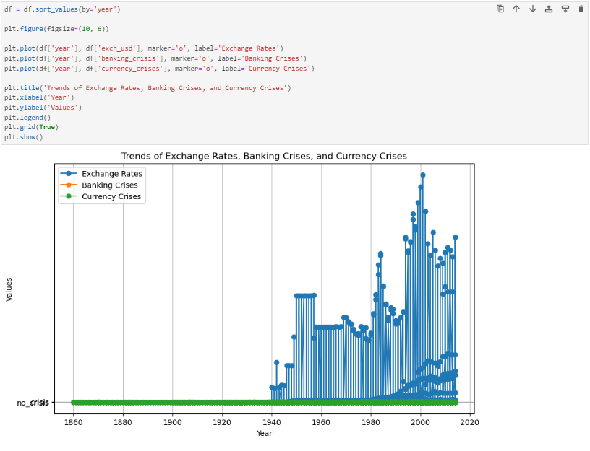

* Some countries have relatively lower exchange rate than other countries. Countries like South Africa, Zambia, Egypt and Morocco has relatively lower exchange rate

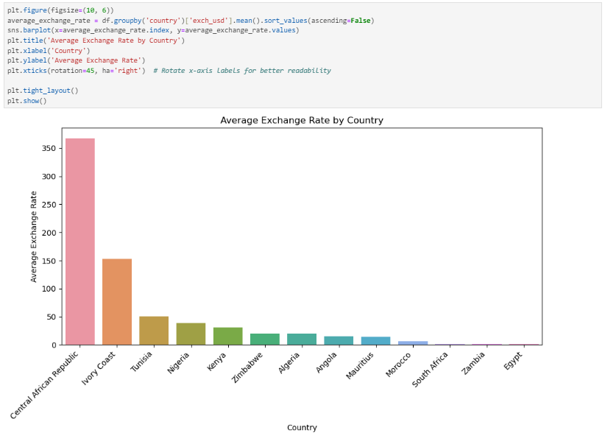

* Occasionally there is a sudden increase in the exchange rate after a steep rise & fall in the inflation rate. However, this can only be seen in countries like Angolo, Nigeria, Tunisia, Zambia and Zimbabwe

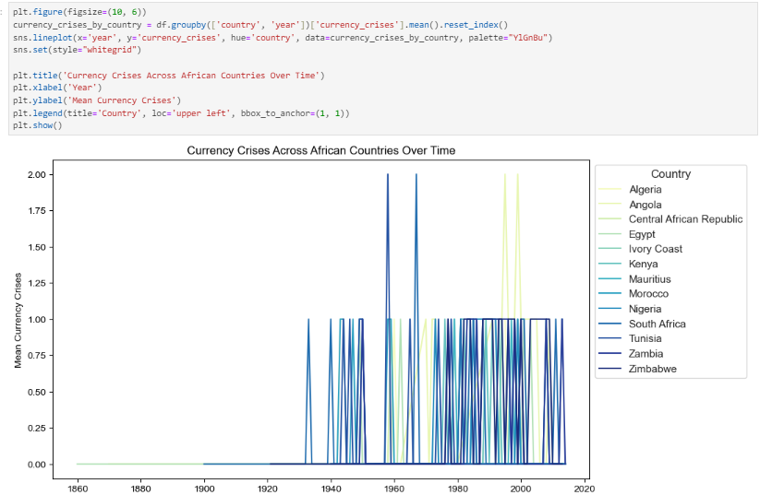

* Most countries that experienced a bank crisis ended up having a higher exchange rate against the US dollar meaning their currency became weaker

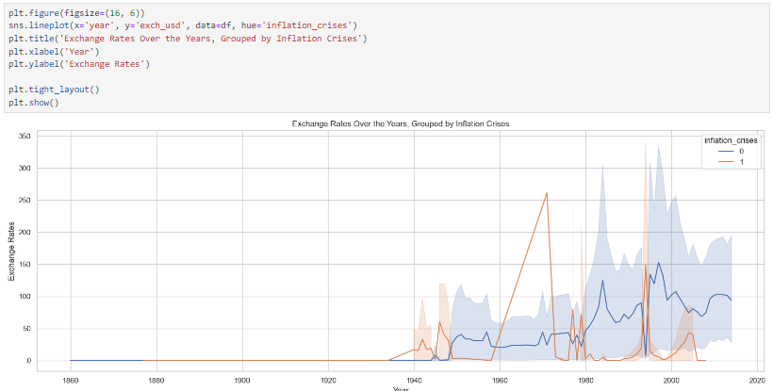

* A banking crisis, commonly linked to a financial crisis, occurs when there is a heightened state of panic or a bank run. In such situations, investors hastily divest assets or withdraw funds from savings accounts due to concerns that the value of their assets might diminish if left within a financial institution. From 1860 to 2014, all countries experienced banking crises, with the most severely affected nations being the Central African Republic, Zimbabwe, Nigeria, Egypt, and Kenya

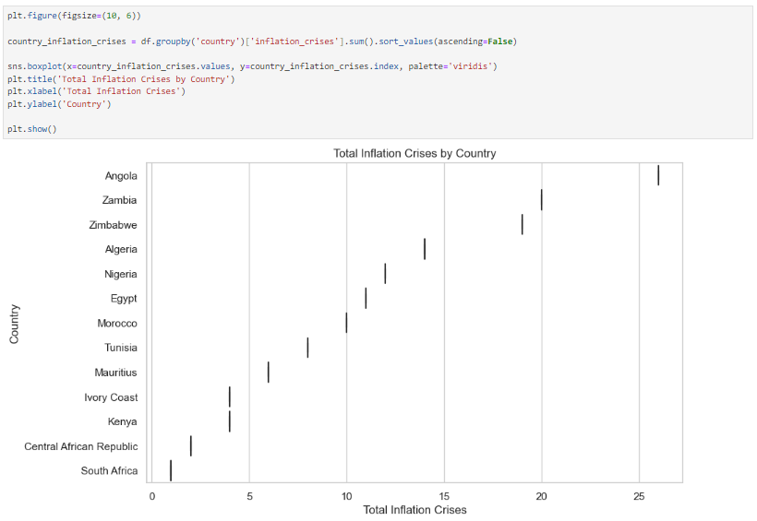

**APPENDIX**

